Preparing New York City Buildings for the Next Pandemic and Year-Round Occupant IAQ and Health
A White Paper by Nick Agopian, President, ReviveAire LLC
The 2020 pandemic decimated the New York City commercial and residential (single-family/multi-family) real estate market. For months in early 2020, NYC resembled a ghost town as COVID-19 fears shut down offices and kept workers at home. Consequently, NYC’s commercial/residential real estate market never fully recovered. Office vacancies hover around the 20% mark today and the city’s residential market has lost more than a half-million inhabitants since 2020.
Thanks to the indoor air quality (IAQ) segment of the HVAC industry however, there’s good news for commercial/residential real estate and its occupants. Recent enhancements in air filtration techniques have been proven to mitigate biological contaminants when another pandemic hits the U.S. Furthermore, these technologies can help mitigate all types of airborne contaminants including flu, common cold, allergens, particulates, PM1.0 and PM2.5 that affect the everyday, overall health of workers. Beyond just general health, IAQ enhancement is documented in numerous studies to improve absenteeism, productivity, cognitive function, and general well-being¹. The facility or city that employs today’s IAQ advancements will have an advantage over its competition.
These filtration modifications require minimal investment because they don’t involve significant infrastructure or HVAC system modifications. Furthermore, they will supplement any facility’s goals in sustainability and energy efficiency.
Adopting ASHRAE 241 Opens the Door to Improving Occupant IAQ
Promoting IAQ is a major goal of The American Society of Heating, Refrigerating and Air-Conditioning Engineers (ASHRAE), a global organization that advances human well-being by focusing on building systems, energy efficiency, refrigeration and sustainability within the industry. Through research, standards writing, publishing and continuing education, ASHRAE develops consensus-based, code enforceable standards.
The NYC Construction Code is already based on a plethora of ASHRAE recommendations such as Standard 62.1 “Ventilation and Acceptable Air Quality“ and Standard 90.1 “Energy Standard for Sites and Buildings Except Low-Rise Residential Buildings.” Therefore, adopting ASHRAE Standard 241 “Control of Infectious Aerosols” is a natural progression in NYC’s quest for modernizing its buildings. Standard 241, which was published in 2023 in the wake of COVID-19, was developed to reduce the risk of infectious aerosol transmission in buildings².
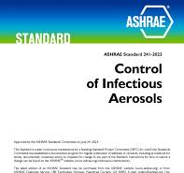
ASHRAE 241 research studies found that increased outdoor air ventilation combined with new innovative air filtration technologies installed in HVAC systems can significantly reduce and mitigate viruses such as SARS CoV-2, the coronavirus that causes COVID-19 disease. Consequently, cities across the nation are now modifying codes to include Standard 241 recommendations with goals of keeping commercial/residential (single-family/multi-family) building occupants healthier during pandemics and especially year-round.
Non-Thermal Plasma-Based Air Filtration
There are three challenges when adding air filtration. The methodology must be proven effective by third-party laboratory studies based on government and ASHRAE-approved test standards. The product must be void of harmful ozone generation. Finally, it should not obstruct the HVAC system’s airflow to the point where it adds substantial energy-inefficient static pressure increases. One ASHRAE 241-recommended filtration methodology that is getting attention from HVAC engineers and facility managers is non-thermal plasma-based filters offered by many manufacturers. It is installed in HVAC systems or ductwork.
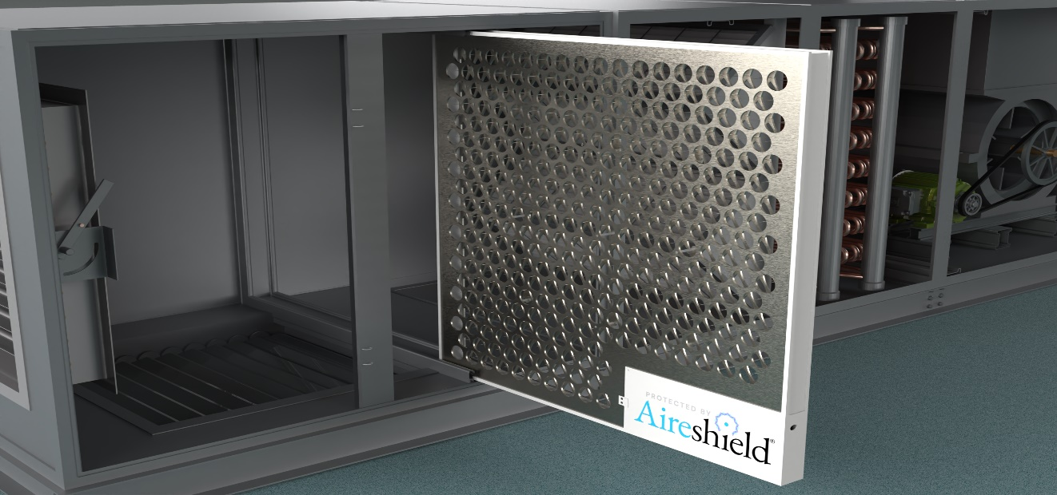
One example is Aireshield by ReviveAire LLC, Kenilworth, NJ. This non-thermal plasma-based system resembles a common one-inch-thick media filter’s size and shape. It is placed upstream of conventional media filters to remove submicron particles and pathogens. Non-thermal plasma-based filters electrostatically charge airstream contaminants with negative and positive charges. The polarity electrically attaches the ions to each other and contaminants. Contaminants, such as PM2.5 and smaller, that were too small for entrapment in conventional HVAC system media filters become enlarged by the agglomeration of negatively and positively charged ion attraction. Consequently, the agglomeration results in filter entrapment and removal from the airstream. Besides entrapment, third party laboratory testing proves the high electric field also inactivates biological contaminants³.
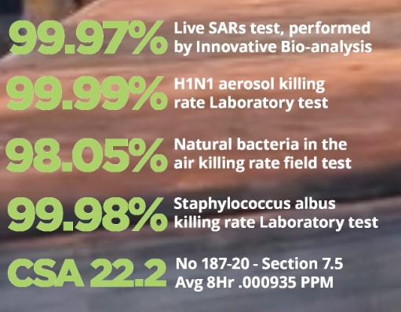
Aireshield is third-party lab test proven to inactivate SARS, all viruses and bacterial contaminants.
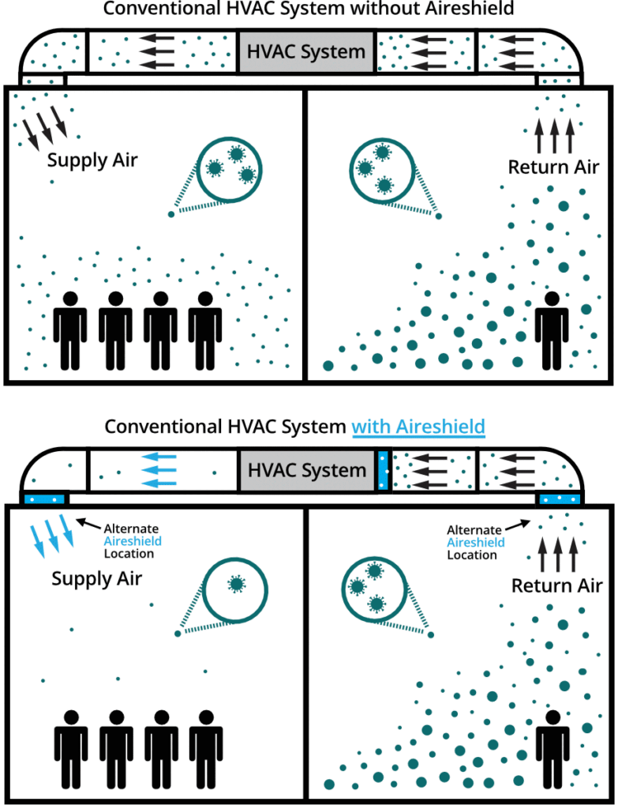
Non-thermal plasma systems typically consist of one-inch-thick filter substrates constructed in a series of 7/8-inch diameter aluminum cylinders (negative) each with a stainless-steel center pin (positive). The series of sleeves and pins offer a very minimal static pressure drop of 0.083-inch W.G. at 300-ft/min. or 0.227-inch at 500-ft/min.
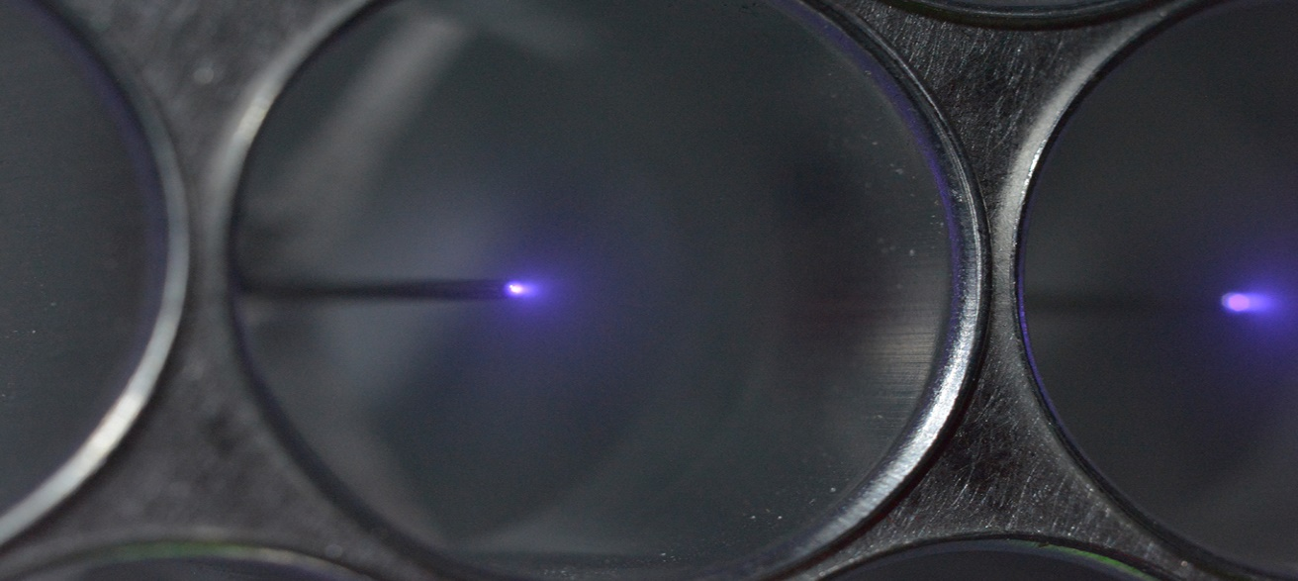
Plasmic filters typically consist of one-inch-thick filter substrates constructed in a series of 7/8-inch diameter aluminum cylinders (negative) each with a stainless-steel center pin (positive).

Other Standard 241 Recommended IAQ Methods
Other filter methods recommended by Standard 241 include Ultraviolet (UV-C) Germicidal Irradiation (UVGI), bipolar ionization and filter media upgrades, such as High Efficiency Particulate Air (HEPA) and Ultra Low Particulate Air (ULPA). These filtration methodologies either don’t perform both filtration particulate capture and disinfection tasks, or they aren’t effective enough unless they generate respiratory-irritating ozone levels the EPA and OSHA consider harmful.
UVGI technology isn’t new and has been used to disinfect air for decades. There’s no doubt UV lamp systems, which are placed in the HVAC system near the DX coil or in ductwork, effectively disinfect biological contaminants especially those that pass two UVGI effectiveness test standards: ANSI/ASHRAE Standard 185.1 for UVGI lamps in in-duct airstream irradiation; and ANCI/ASHRAE Standard 185.2 for UVGI lamps for in-duct surface irradiation.
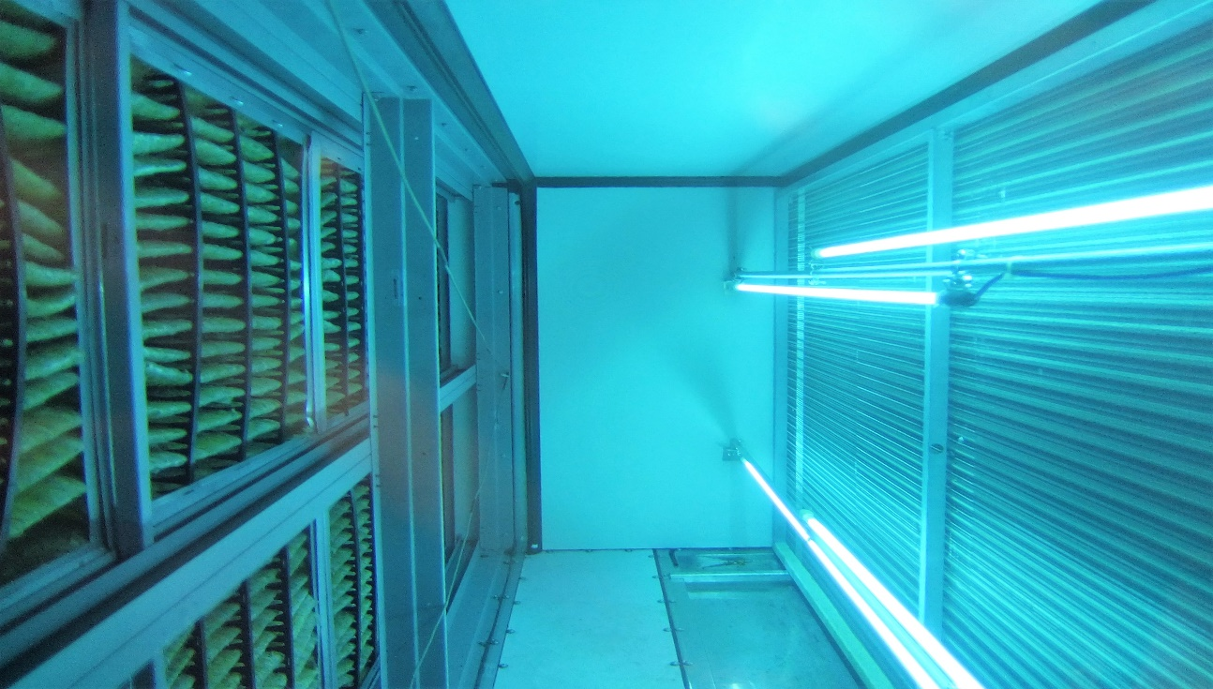
UVGI Lamps placed between the filters and the DX coil in a commercial office building HVAC air handler.
UVGI’s inability to perform particulate collection is a disadvantage. All UV-C technologies for HVAC systems generate some level of ozone. Thus, UV-C products should be avoided that aren’t certified by third party labs outlined by the test standard, UL2998 “Environmental Claim Validation program for Zero Ozone Emissions from Air Cleaners.” Multiple studies have proven that excessive ozone levels are harmful to human respiratory systems. While ozone is sometimes an unintended byproduct, some UV-C lamp systems may also intentionally produce ozone by design. For example, some manufacturers purposefully use specific UV wavelengths that create ozone to produce the distinct, clean-smelling ozone odor. Due to increasing consumer demands and pressure from regulatory authorities, electronic air cleaners including non-thermal plasma-based filtration and other air cleaning device manufacturers must engage with independent third parties to demonstrate UL2998 compliance of their products’ ozone emission levels. Ozone levels are critical because the EPA has proven ozone as detrimental to respiratory systems⁴. Non-thermal plasma-based filtration, such as Aireshield, is safe to specify and is verified as acceptable near-zero ozone compliance with UL2998.
Ionization, sometimes referred to as bipolar ionization, creates airborne ions from a generator installed inside the HVAC system. Positive and negatively charged ions are generated from an ionizer and distributed throughout the occupied space via the HVAC system ductwork. Once in the space, they electronically attach to particulates to enlarge them. The return air duct transports agglomerated contaminants for entrapment in the HVAC system’s conventional filters. The disadvantage is that the ions dissipate in just a few minutes inside their destination space. The ions can also prematurely dissipate in long commercial ductwork runs. The ionization process also generates ozone, therefore manufactures have recently reduced their ionization outputs to comply with new ozone verification test standards, such as UL2998. Unfortunately, the reductions decrease ionization systems’ effectiveness.
HEPA and ULPA are excellent at sub-micron particulate entrapment. HEPA is 99.97% effective in capturing dust, pollen, mold, bacteria, and any airborne particles with a size of 0.3 microns (µm). ULPA is 99.999% effective at removing particulates 0.12-micron diameter or larger. Unfortunately, both filter types only entrap pathogens and don’t disinfect them. Entrapped pathogen spores can still reproduce because HEPA and ULPA don’t inactivate them or alter their DNA like UV-C, ionization and non-thermal plasma methodologies. Those highly dense weaves that facilitate successful particulate capture also increase system static pressure, which in turn, decreases energy efficiency.
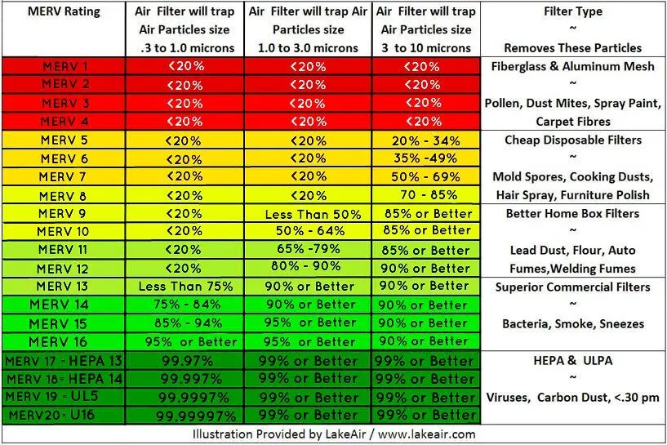
HEPA and ULPA media replacement is also expensive. Replacement during a pandemic requires hazardous material safety protocols to handle entrapped living pathogens.
By contrast, the non-thermal plasma system disinfects pathogens and agglomerates them for capture in common filters. Semi-annual maintenance requires the reusable substrate to be quickly removed, vacuumed, or brushed for two minutes, and then returned to its airstream position. Besides the airstream, non-thermal plasma systems also keep the HVAC interiors and DX coil clean of biofilm, the latter which can result in up to a 30% reduction in heat transfer efficiency. Properly maintained non-thermal plasma-based systems have lifespans 10 years or more because there are no moving parts.
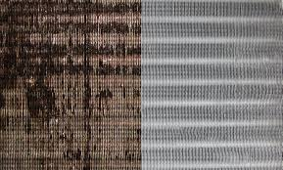
Mold, mildew and biofilm can thrive in the dark, humid environs of an HVAC system. A non-thermal plasma system maintains HVAC unit interiors free of biological contaminants that can reduce efficiency by 30%.
Sustainability and Energy Savings
Applying additional outdoor air and employing an air filtration device to optimize IAQ should be a balance between the two methods. Applying excessive outdoor air ventilation is effective, but inner-city air quality is poor from pollutants, such as vehicle emissions and unpredictable wildfire smoke/haze events. Increasing outdoor air is also cost prohibitive because it must be cooled or heated to occupant temperature setpoints with energy intensive air conditioning or electric heat. Instead, air filtration methods such as non-thermal plasma can offset the need for additional, code-exceeding outdoor air minimums.
Non-thermal plasma systems present minimal static pressure losses compared to denser, upgraded particulate media filters, such as MERV 13, HEPA and ULPA, that are inherently energy inefficient due to high static pressure.
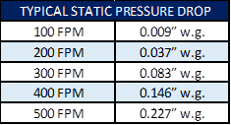
Aireshield can transform common MERV 8 and MERV 13 media filters into the performance of a MERV 13 and HEPA filter, respectively, but without the static pressure increases associated with that denser media.
The majority of commercial/residential HVAC systems today were designed to use inexpensive MERV 8 media filters that capture only 70 - 80% of particulates 3- microns and larger. The trade-off is energy savings because their free-flowing media weaves don’t pose a significant static-pressure loss of thicker medias.
However, using a non-thermal plasma system can upgrade HVAC systems’ MERV 8 and MERV 13 filter particulate capture performances to MERV 13 and HEPA levels, respectively, but without the associated static pressure increases. Consequently, MERV 8 filters will capture 90% of airstream particulates (1.0 to 10-micron size), because the contaminants have become enlarged for entrapment via the agglomeration process. MERV 13 filter performances will be enhanced to 99.97% (.3 to 10-micron size).
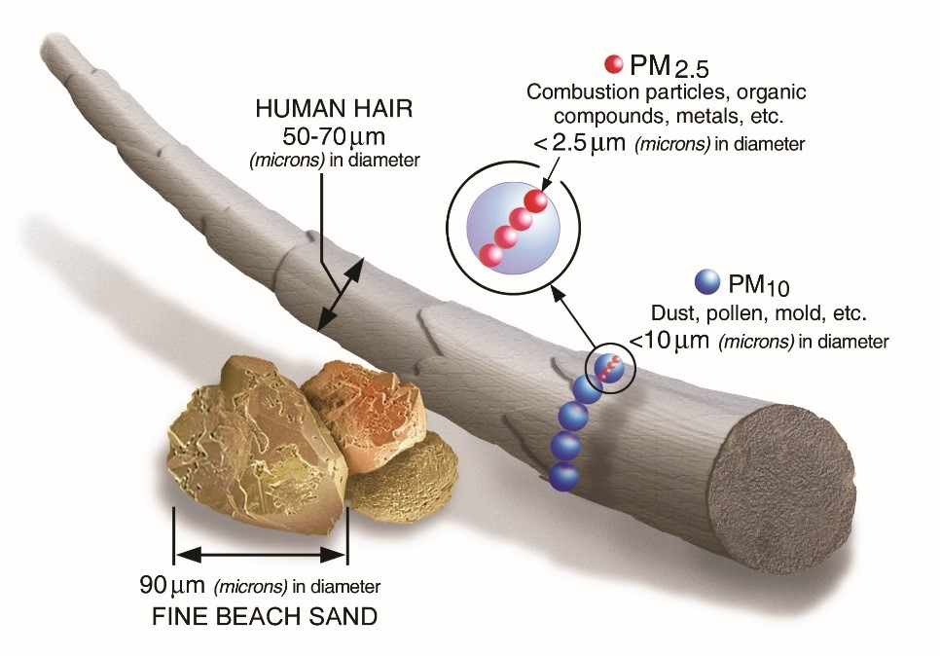
Besides energy savings, using more sustainable MERV 8 filters can result in substantial energy and replacement media savings versus upgrading to more expensive MERV 13 and HEPA filters. HEPA filters and MERV 13 filters cost 10 times and 2 times more than MERV 8 filters, respectively. Furthermore, the HVAC systems designed or retrofitted for MERV 13 and HEPA filters require larger horsepower fans to offset static pressure increases. This results in higher capital equipment costs and more energy consumption.
Government facilities and schools are currently adopting Standard 241, to lessen the effects of the next pandemic and promote everyday occupant well-being. NYC, as well as other major U.S. cities will soon adopt ASHRAE Standard 241. Complying commercial/residential (single-family/multi-family) real estate owners will profit from more energy-efficient, sustainable, safe, and healthy workspaces that mitigate pathogens during future pandemic periods. Occupants will also benefit from everyday exposure to allergens, flu, the common cold, VOCs, CO₂ and other contaminants of concern. Consequently, office building tenants enjoy less employee absenteeism, higher productivity and healthier environments that increase occupant well-being.
ASHRAE 241 and inexpensive, drop-in air filtration retrofits such as Aireshield’s non-thermal plasma technology can be a win/win proposition for NYC, its inhabitants, and the commercial/residential (single-family/multi-family) real estate market.
###
- https://www.hsph.harvard.edu/event/how-air-pollution-impacts-our-brains/#:~:text=Mounting%20evidence%20links%20air%20pollution,risk%20for%20anxiety%20and%20depressionhttps://www.airnow.gov/sites/default/files/2020-02/ozone-c.pdf
- https://www.ashrae.org/technical-resources/bookstore/ashrae-standard-241-control-of-infectious-aerosols
- https://www.ncbi.nlm.nih.gov/pmc/articles/PMC9785490/
- https://papers.ssrn.com/sol3/papers.cfm?abstract_id=4409736

